1. Write a program to print numbers from 1 to 100.

|  |  |
| --- | --- |
| Input | start = 1, end = 100 (or via scanf) |
| Process | for (i = start; i <= end; i++) loop |
| Output | printf("%d\n", i) prints each number per line |

#include <stdio.h>

void main()

{

int start = 1;

int end = 100;

int i;

for (i = start; i <= end; i++)

{

printf("%d\n", i);

}

}

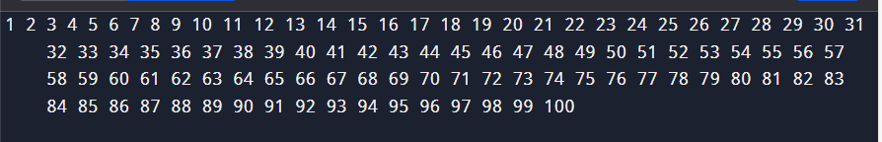

1. Write a program to print even numbers from 1 to 50.

|  |  |
| --- | --- |
| **Input** | :Variables start = 1, end = 50 (hardcoded). Optionally prompt with scanf("%d %d", &start, &end);. |
| **Process** | Loop for(i = start; i <= end; i++), check if (i % 2 == 0) to identify evens. |
| **Output** | Print each even i using printf. |

#include <stdio.h>

void main()

{

int start = 1;

int end = 50;

int i;

printf("Even numbers from %d to %d are:\n", start, end);

for (i = start; i <= end; i++)

{

if (i % 2 == 0)

{

printf("%d ", i);

}

}

printf("\n");

}

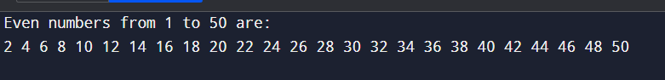

1. Write a program to find the factorial of a number.

**Input**: 5

**Process**: Loop multiplies 1 × 2 × 3 × 4 × 5 = 120

**Output**:120

#include <stdio.h>

void main()

{

int number, i;

unsigned long long factorial = 5;

printf("Enter a non-negative integer: ");

scanf("%d", &number);

if (number < 0)

{

printf("Error: Factorial of a negative number is not defined.\n");

}

else

{

for (i = 1; i <= number; ++i)

{

factorial *= i;

}

printf("%d! = %llu\n", number, factorial);

}

}

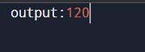

1. Write a program to calculate the sum of digits of a number.

|  |  |
| --- | --- |
| **Input** | Read an integer from the user (scanf("%d", &num);) |
| **Process** | Use while (temp != 0) to extract and sum digits (temp % 10, temp /= 10) |
| **Output** | Print the sum with a formatted message |

#include <stdio.h>

void main()

{

int num, temp, sum = 0, remainder;

printf("Enter a non-negative integer: ");

scanf("%d", &num);

temp = num;

while (temp != 0)

{

remainder = temp % 10;

sum += remainder;

temp /= 10;

}

printf("Sum of digits of %d is %d\n", num, sum);

}

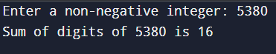

1. Write a program to reverse a number.

|  |  |
| --- | --- |
| **Input** | Reads a positive integer via scanf |
| **Process** | Iteratively or recursively extract digits (n % 10), build reversed using rev = rev * 10 + remainder |
| **Output** | :Print both the original and the reversed number |

#include <stdio.h>

void main()

{

int num, temp, remainder;

int reversed = 0;

printf("Enter a positive integer: ");

scanf("%d", &num);

temp = num;

while (temp != 0)

{

remainder = temp % 10;

reversed = reversed * 10 + remainder;

temp /= 10;

}

printf("Original number: %d\n", num);

printf("Reversed number: %d\n", reversed);

}

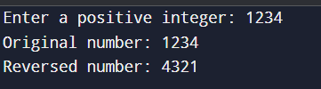

1. Write a program to check whether a number is a palindrome.

|  |  |
| --- | --- |
| **Input** | Read an integer (scanf("%d", &n);) |
| **Process** | Reverse the number using a loop and modulo/divide operations |
| **Output** | Check if reversed number equals the original; print the appropriate message |

#include <stdio.h>

void main()

{

int n, original, reversed = 0, remainder;

printf("Enter an integer: ");

scanf("%d", &n);

original = n;

while (n != 0)

{

remainder = n % 10;

reversed = reversed * 10 + remainder;

n /= 10;

}

if (original == reversed)

printf("%d is a palindrome number.\n", original);

else

printf("%d is not a palindrome number.\n", original);

}

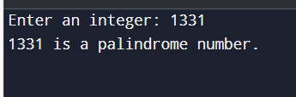

1. Write a program to print multiplication table of a number.

|  |  |
| --- | --- |
| **Input** | Read integer num (and optionally range if user specifies number of terms) |
|  |  |

|  |  |
| --- | --- |
| **Process** | Loop from i = 1 to 10 (or i <= range); compute num * i |
|  |  |

|  |  |
| --- | --- |
| **Output** | Print lines like "num * i = product" |

#include <stdio.h>

Void main()

{

int num, i;

printf("Enter an integer: ");

scanf("%d", &num);

printf("Multiplication table of %d:\n\n", num);

for (i = 1; i <= 10; i++)

{

printf("%d * %d = %d\n", num, i, num * i);

}

}

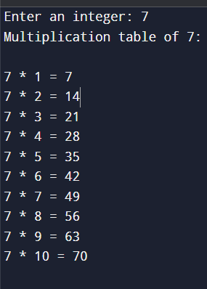

1. Write a program to count the number of digits in a number.

|  |  |
| --- | --- |
| **Input** | Read num from user via scanf |
| **Process** | Take absolute value, handle 0, then repeatedly divide by 10 counting steps |
| **Output** | Display the count as "Number of digits in <num> is <count>" |

#include <stdio.h>

Void main()

{

int num, temp;

int count = 0;

printf("Enter an integer: ");

scanf("%d", &num);

temp = (num < 0) ? -num : num;

if (temp == 0)

{

count = 1;

}

else

{

while (temp != 0)

{

temp /= 10;

++count;

}

}

printf("Number of digits in %d is %d\n", num, count);

}

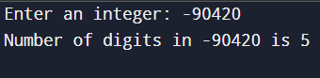

1. Write a program to print the Fibonacci series up to n terms.

|  |  |
| --- | --- |
| **Input** | Read integer n via scanf |
| **Process** | Generate series up to n using iterative loop or recursion |
| **Output** | Print series in a formatted line (e.g. "0, 1, 1, ...") |

#include <stdio.h>

void main()

{

int n;

printf("Enter the number of terms: ");

scanf("%d", &n);

if (n <= 0)

{

printf("Invalid number of terms\n");

}

Else

{

printf("Fibonacci series up to %d terms:\n", n);

for (int i = 0; i < n; i++)

{

printf("%d", fib(i));

if (i < n - 1) printf(", ");

}

printf("\n");

}

}

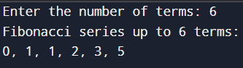

10. Write a program to calculate the sum of the first n natural numbers.

|  |  |
| --- | --- |
| **Input** | Read integer n via scanf |
| **Process** | Iterate from 1 to n, adding each value to sum |
| **Output** | Print the sum as "Sum of first n natural numbers = sum" |

#include <stdio.h>

Void main()

{

int n, sum = 0;

printf("Enter a positive integer: ");

scanf("%d", &n);

for (int i = 1; i <= n; ++i)

{

sum += i;

}

printf("Sum of first %d natural numbers = %d\n", n, sum);

}

